# **Sending Messages to Event Hub**

This demo is about sending messages to an event hub that is already created. Before starting the demo, make sure to create an event hub. For creation of event hub, refer previous demo.

Open visual studio and go to **File -> New -> Project.**

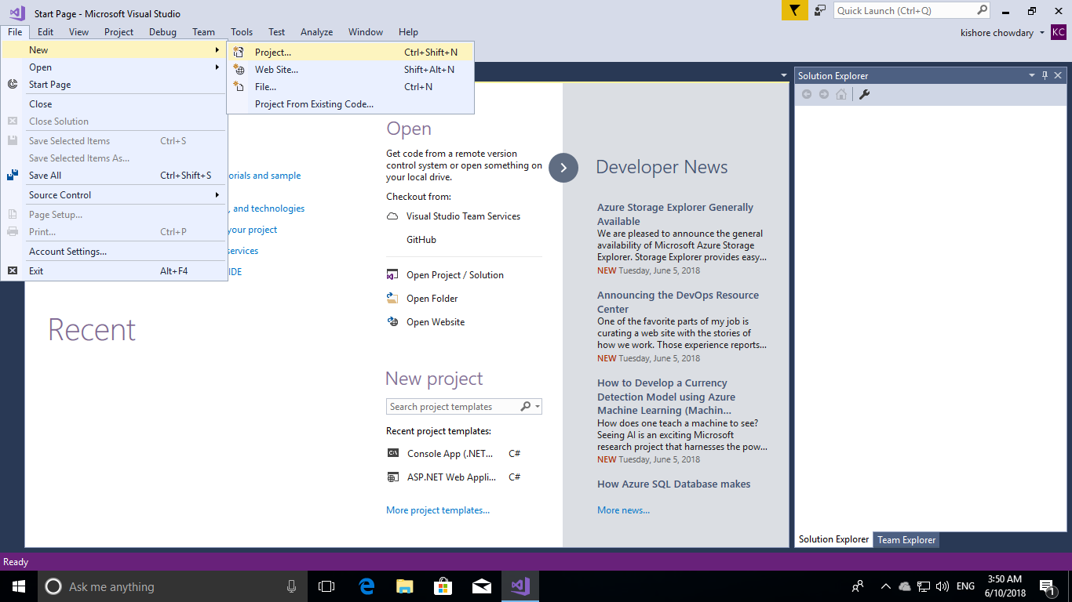

Under **.Net Core** Template, choose **Console App (.Net Core),** name it and click on **Ok.**

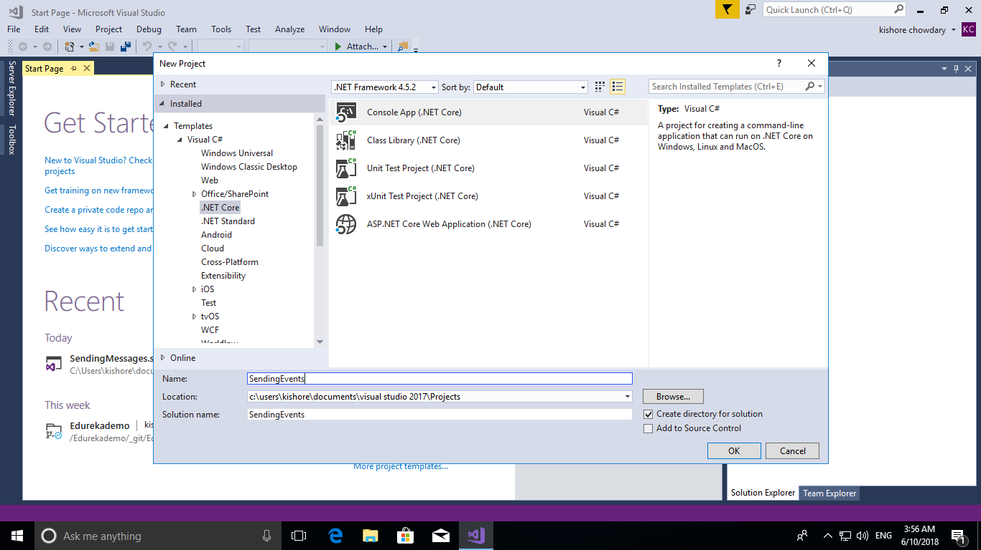

After the solution gets created, right click the solution in the right and click on **Manage NuGet Packages** to add required packages for this demo.

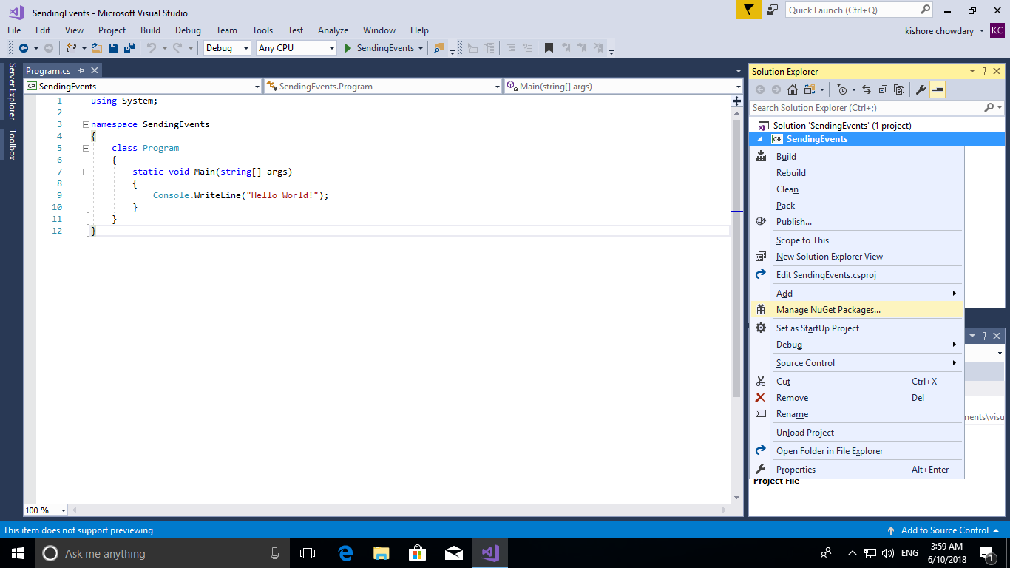

Click on **Browse** and search for **Microsoft.Azure.EventHubs** and hit on **Install.** Accept the terms when prompted during the installation process. After this, click on **Program.cs** in the right side to write code for sending messages.

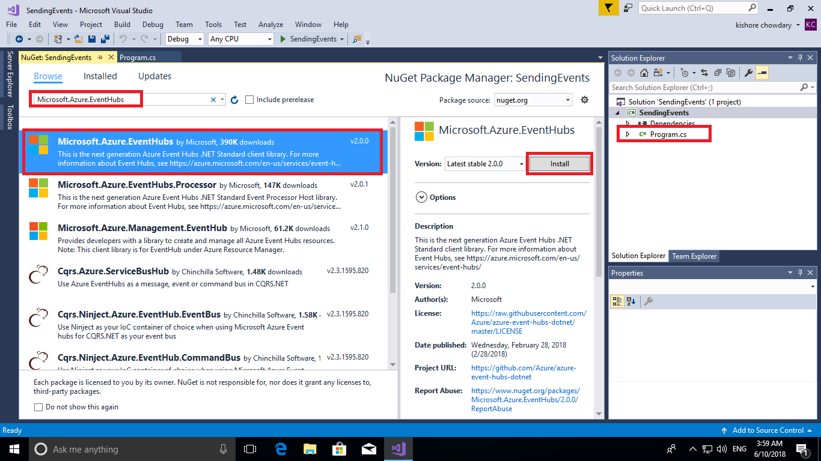

Go to the portal and open the event hub that you have created and in the left side menu click on **Shared Access Policies.** In there copy the **Connection String** which is required to connect our application to send messages to event hub.

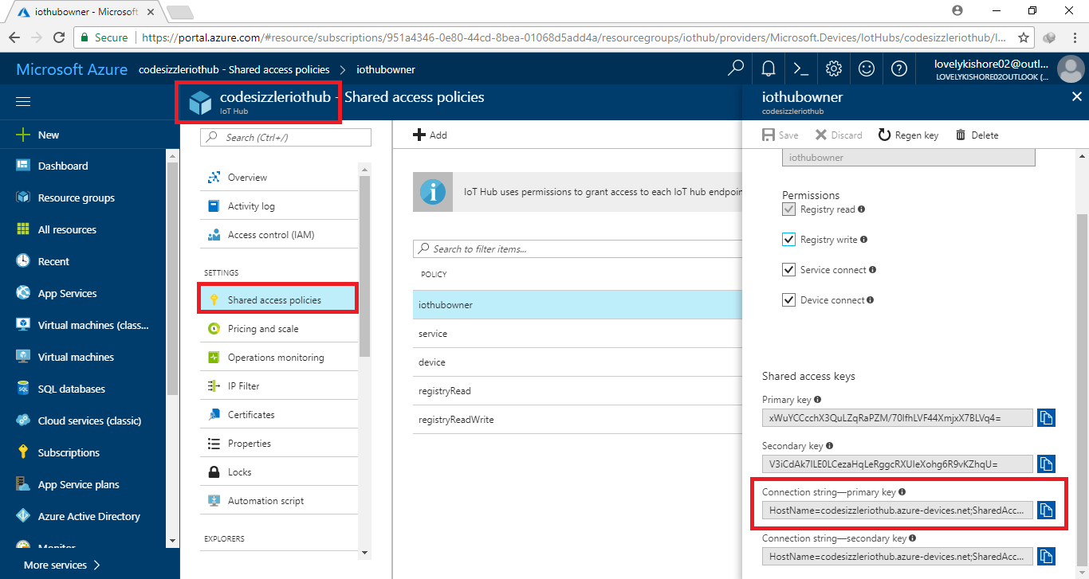

Paste the below given code in the **Program.cs** page and paste your event hub’s connection string and the event hub name. It is denoted in the below given screenshot and code as well.

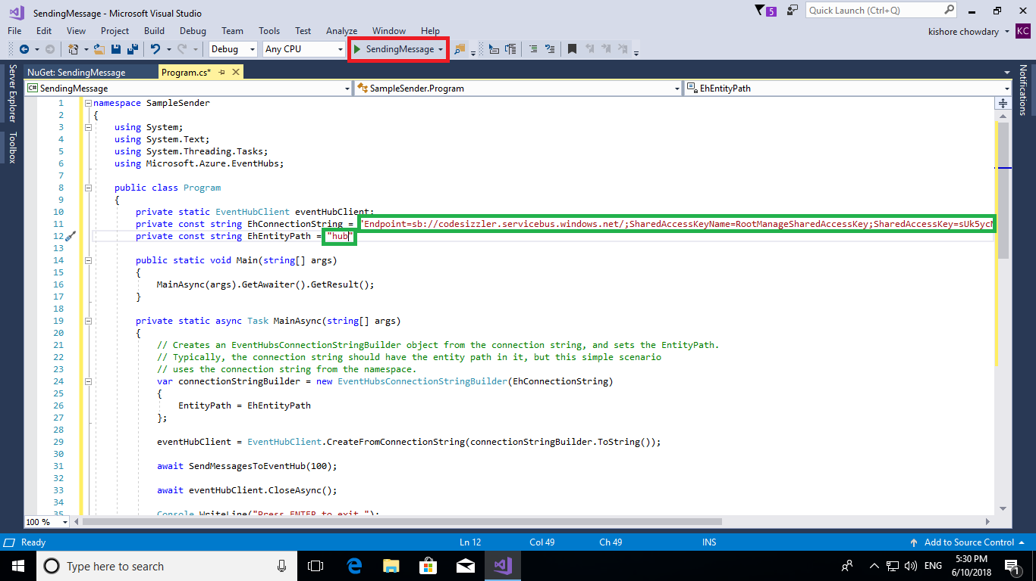

**Program.cs:**

namespace SampleSender

{

using System;

using System.Text;

using System.Threading.Tasks;

using Microsoft.Azure.EventHubs;

public class Program

{

private static EventHubClient eventHubClient;

private const string EhConnectionString = "{Event Hubs connection string}";

private const string EhEntityPath = "{Event Hub path/name}";

public static void Main(string[] args)

{

MainAsync(args).GetAwaiter().GetResult();

}

private static async Task MainAsync(string[] args)

{

// Creates an EventHubsConnectionStringBuilder object from the connection string, and sets the EntityPath.

// Typically, the connection string should have the entity path in it, but this simple scenario

// uses the connection string from the namespace.

var connectionStringBuilder = new EventHubsConnectionStringBuilder(EhConnectionString)

{

EntityPath = EhEntityPath

};

eventHubClient = EventHubClient.CreateFromConnectionString(connectionStringBuilder.ToString());

await SendMessagesToEventHub(100);

await eventHubClient.CloseAsync();

Console.WriteLine("Press ENTER to exit.");

Console.ReadLine(); }

// Creates an event hub client and sends 100 messages to the event hub.

private static async Task SendMessagesToEventHub(int numMessagesToSend)

{

for (var i = 0; i < numMessagesToSend; i++)

{

try

{

var message = $"Message {i}";

Console.WriteLine($"Sending message: {message}");

await eventHubClient.SendAsync(new EventData(Encoding.UTF8.GetBytes(message)));

}

catch (Exception exception)

{

Console.WriteLine($"{DateTime.Now} > Exception: {exception.Message}");

}

await Task.Delay(10);

}

Console.WriteLine($"{numMessagesToSend} messages sent.");

}

}

}

After making changes to the code, click on **Run** button at the top or press **F5** button to execute the code. This will show you the output.

